**Open Configurable Networks Lab1**

**Todo: Deploy amplitude and frequency modulation systems using Pluto SDR. We will look into receiver models for AM (including double side band receivers) and attempt to receive a broadcast message from the transmitting node (based on a Pluto SDR). It is recommended to read up on AM systems include complex-envelope models, coherent and non-coherent detection (some details are provided in the appendix).**

The block design structure of the project is shown as below.

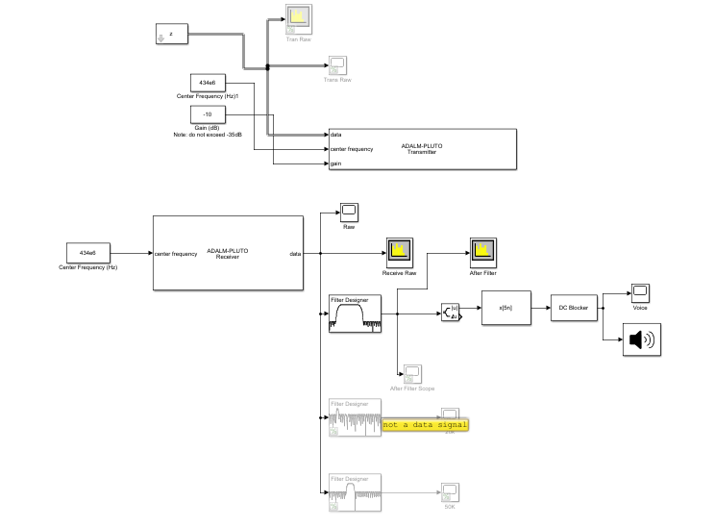

1. Block Design Structure
2. **Screen shot and notes from AM observations.**

Transferring the signal from z_files.mat, we could observe the spectrum as below.

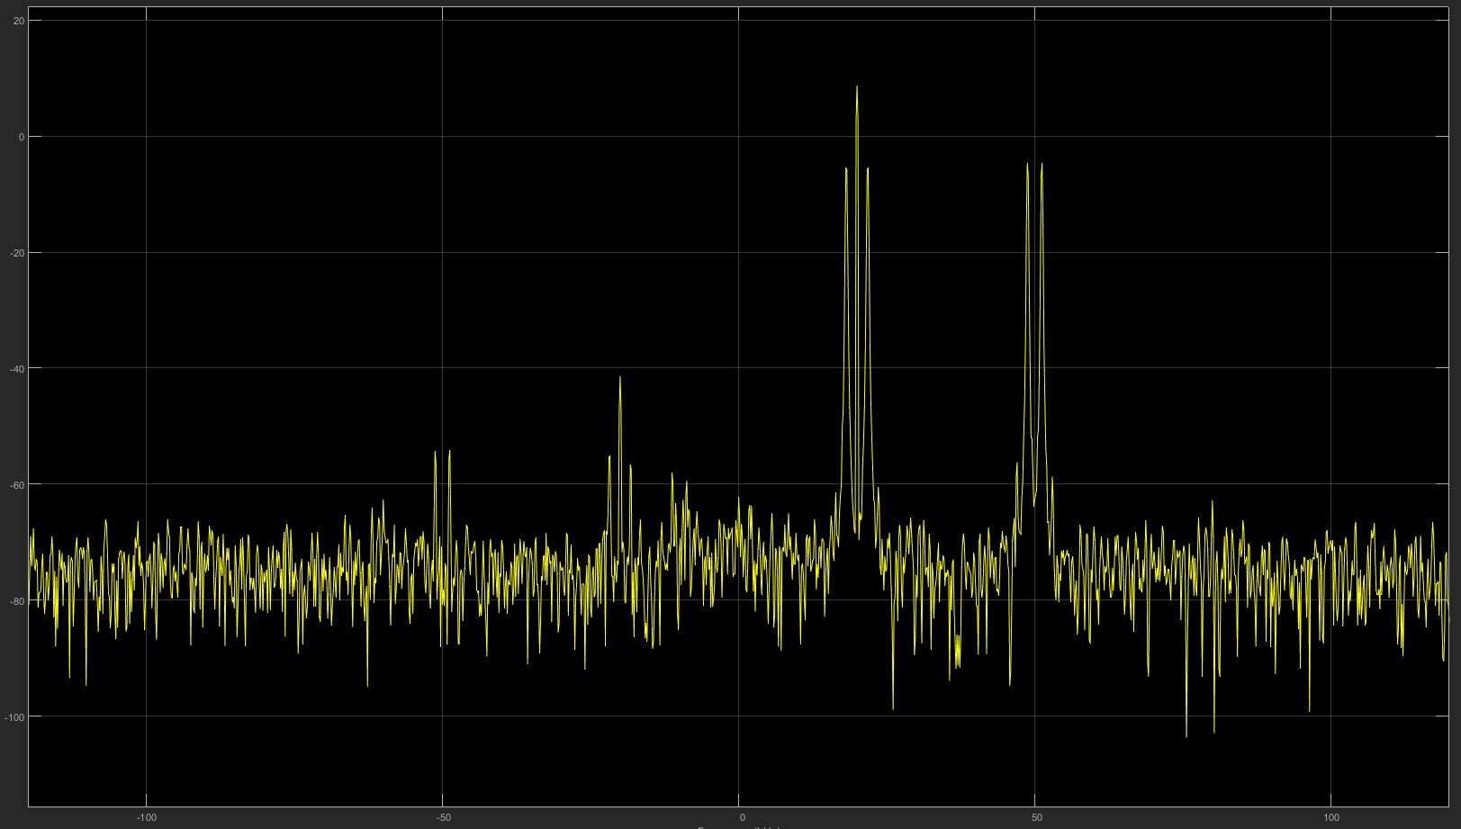

1. AM spectrum
2. **Screen capture of the time-domain signal**

The time domain signal with AM is shown as below.

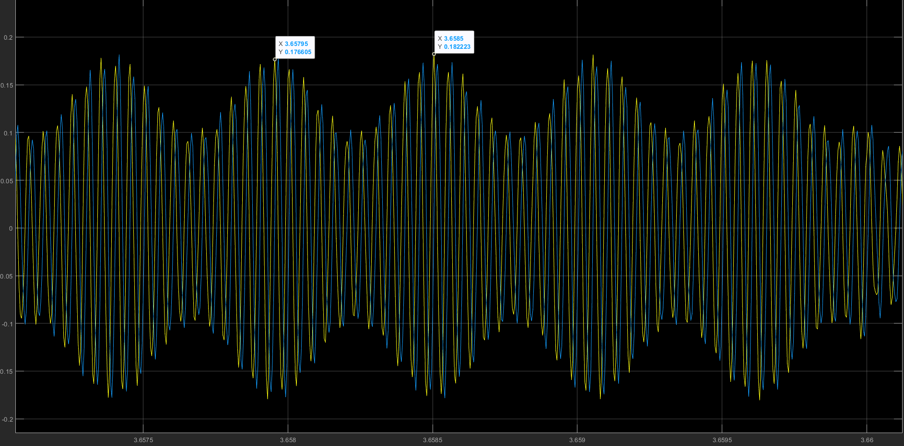

1. AM in Time Domain
2. **Observations form DSBAM receiver model (spectrum analyzer captures)**

We can observe the spectrum of the DSBAM receiver model as below.

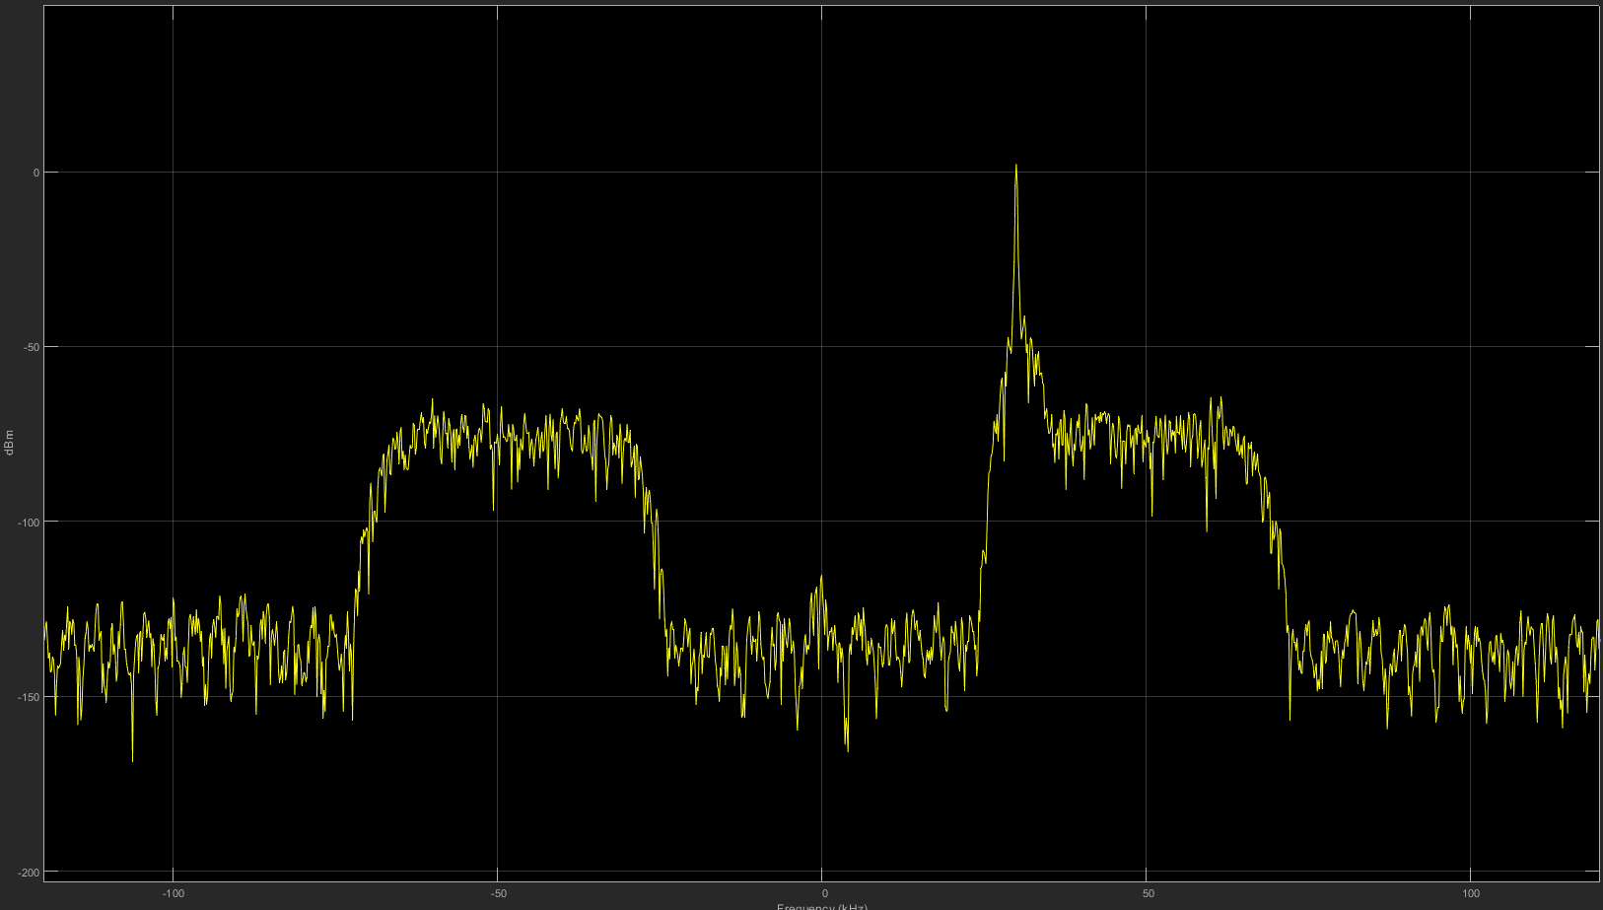

1. DSBAM Spectrum

We can see that the signal is located at the frequency range around 30kHz, so we can design the bandpass filter with the parameters as below to get the voice signal and filter the other noise.

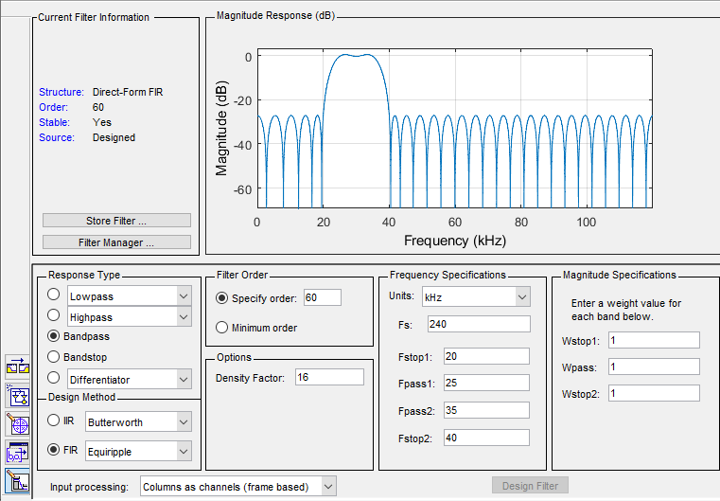

1. DSBAM filter

With the demodulation and get the Re part, we could get the original signal, then we need to make the FIR decimation and eliminate the DC weight. The we could recover the voice signal in time domain as below. It is a conversation between a man and a woman, with a background music. The voice waveform in time domain is shown as below.

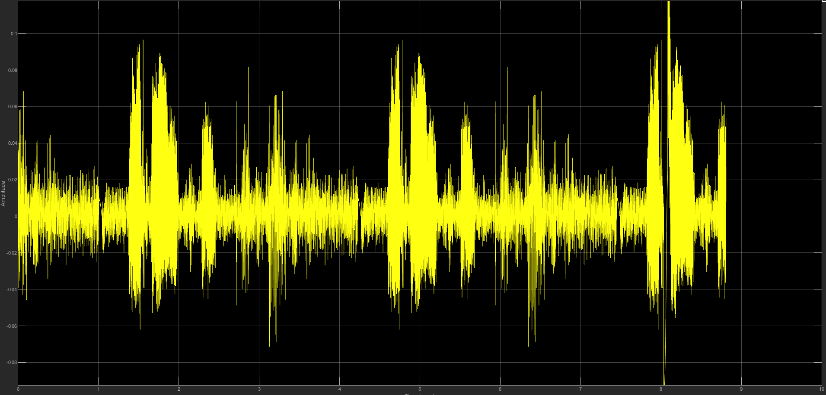

1. Voice signal in time domain
2. **Thoughts on question 1.1 through 1.6**

**Question 1.1: On a screenshot of the spectrum analyzer, identify the DSBAM, DSB-SC and their sidebands (you may annotate or define them in the text).**

We can observe two signals in this spectrum that one central frequency is 20 kHz and another one is 50 kHz. As we known and mentioned in the appendix, the difference between the DSBAM and DSB-SC is that the carrier level of DSB-SC will be completely suppressed. So, we can tell that the spectrum on the left in using DSBAM and the right one is using DSC-SC as we marked below.

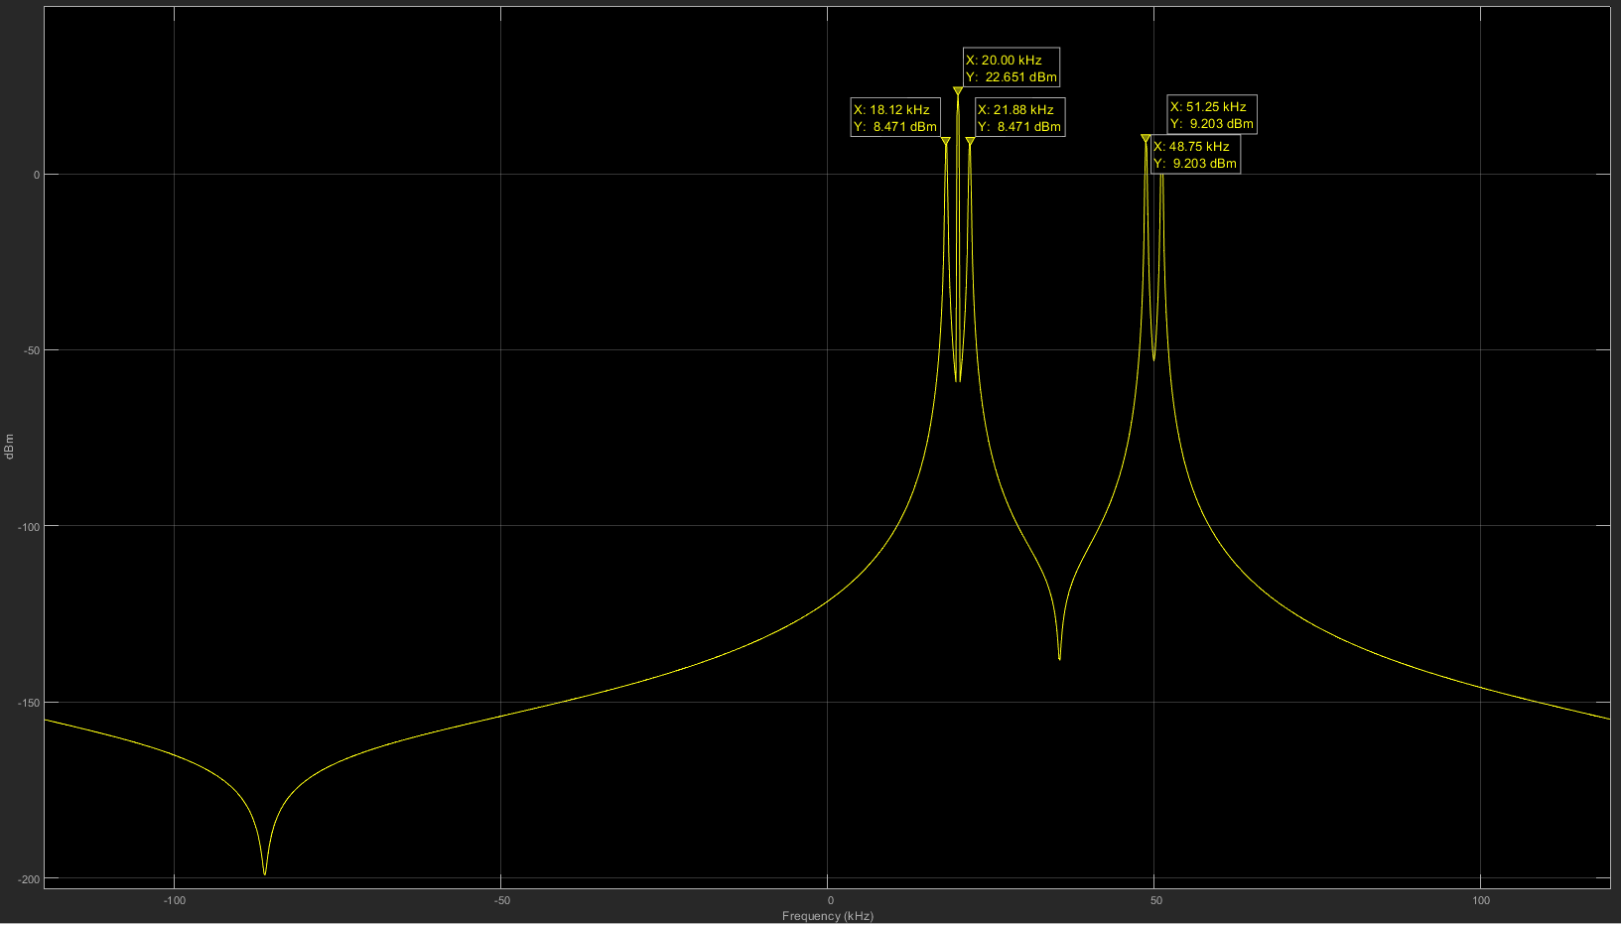

DSB AM (20kHz)

And

Their Sidebands

(18.12kHz

21.88kHz

)

DSB-SC (50kHz)

And

Their Sidebands

(48.75kHz

51.25kHz

)

1. Spectrum of DSB-AM and DSB-SC and their side bands

**Question 1.2: Determine the actual carrier frequency of the DSBAM and the DSB-SC passband waveform?**

The carrier frequency of DSB AM is 20kHz, and for DSB-SC, it is 50kHz.

**Question 1.3: Can you determine the message frequency of the DSBAM communication signal?**

Take the signal to the baseband, we can tell that the frequency of the original message signal around 20kHz is 1.88kHz, and the other one is 1.25kHz.

**Question 1.4: Configure the filters appropriately to see both the DSB-SC and DSBAM waveforms. Are you able to identify message frequency from the time-domain plots?**

To get the individual signal, we need to design the bandpass filters. The filter for the DSB-AM will be around 20kHz. The parameters of this filter are shown as below.

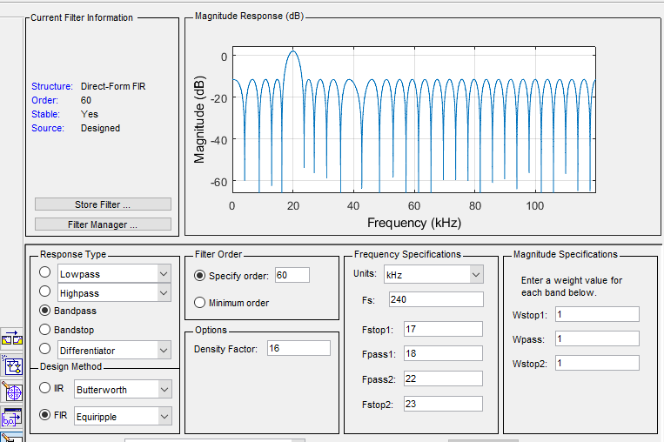

1. Filter parameters for DSB-AM

With this filter, we can get the waveform in the time domain as below. We can mark the peak value of the sin waveform and estimate the frequency is about 1.8kHz.



1. DSB-AM waveform in time domain

The filter for the DSB-SC will be around 50kHz. The parameters of this filter are shown as below.

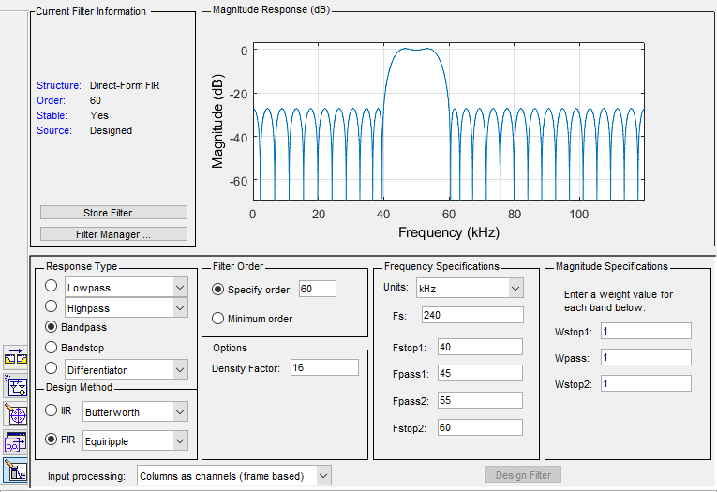

1. Filter parameters for DSB-SC

With this filter, we can get the waveform in the time domain as below. We can mark the peak value of the sin waveform and estimate the frequency is about 2.5kHz.

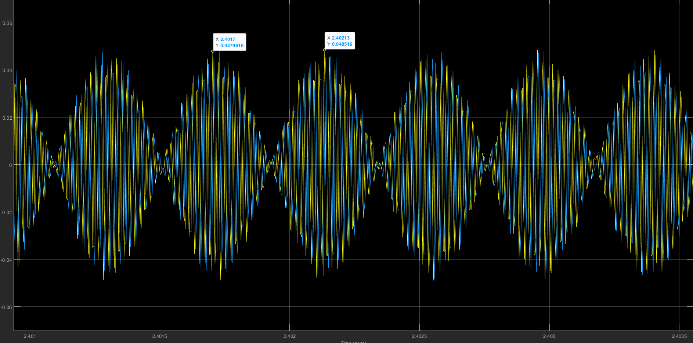

1. DSB-SC waveform in time domain

**Question 1.5: What happens to the recovered audio when you adjust the gain of the SDR receiver block? Summarize your findings.**

When we are using the gain as 40, we can observe the voice signal and the spectrum as below. It is obvious that some distortion and noise is introduced to the voice because of the too high value of the gain, it means that the noise signal is also gained by the receiver which will impact the message signal.

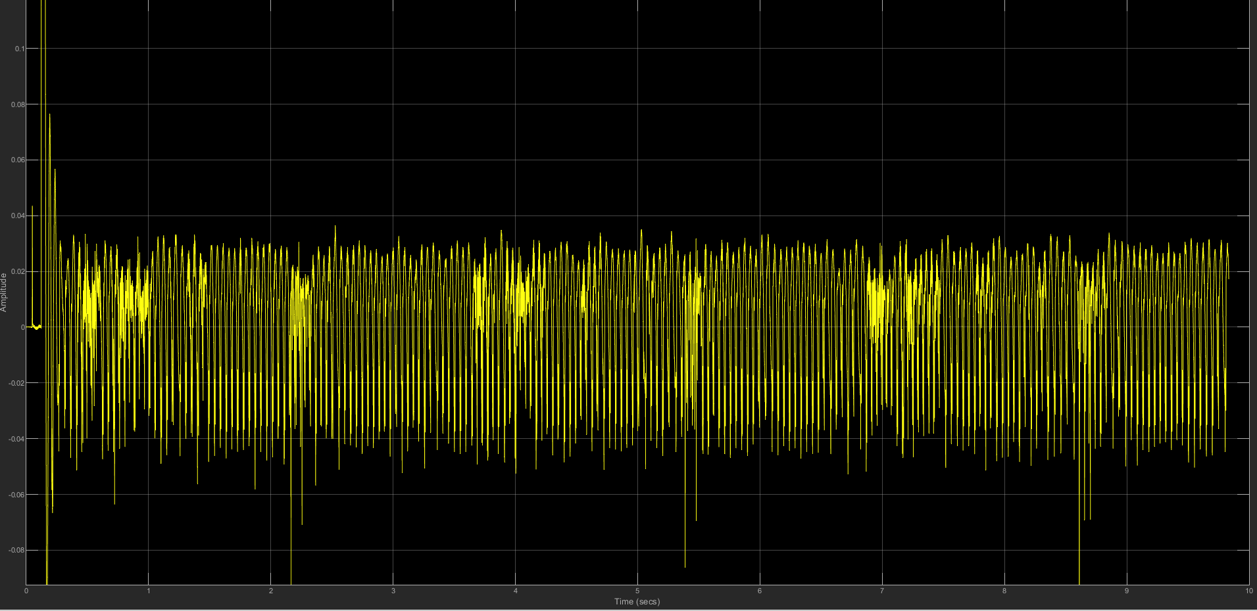

1. Voice Signal in time domain (gain = 40)

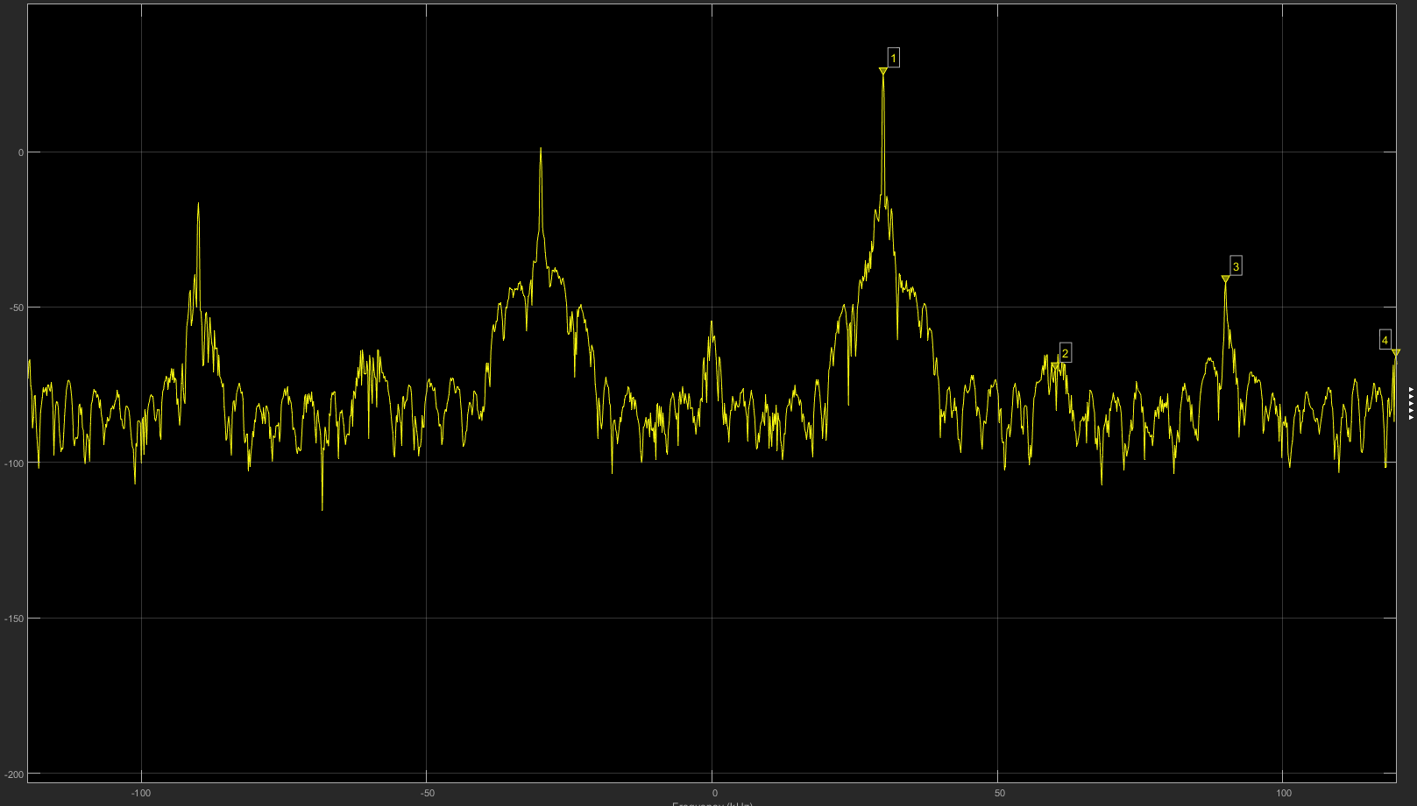

1. Spectrum (gain = 40)

When we try to decrease the gain to 10, we can see the noise is effectively removed both from the voice time domain signal and the spectrum. The voice could be much clearer.



1. Voice Signal in time domain (gain = 10)



1. Spectrum (gain = 10)

**Question 1.6: What happens when you remove the Bandpass Filter from the model? [You can do this easily by right clicking the block and selecting “Comment Through”]. Summarize your findings.**

When we comment through the bandpass filter from the model, we can see some distortion is introduced and the in the spectrum will also be changed that we can’t see the window of the filter.

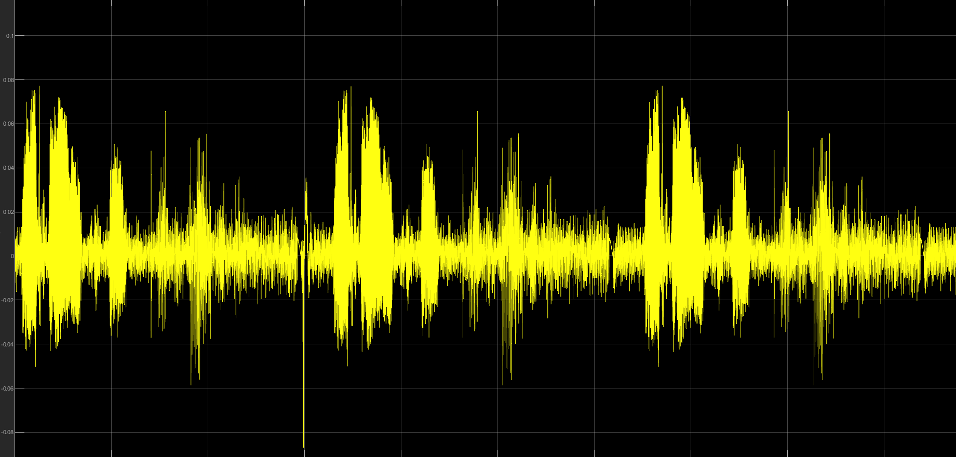

1. Voice signal in time domain (comment through the filter)

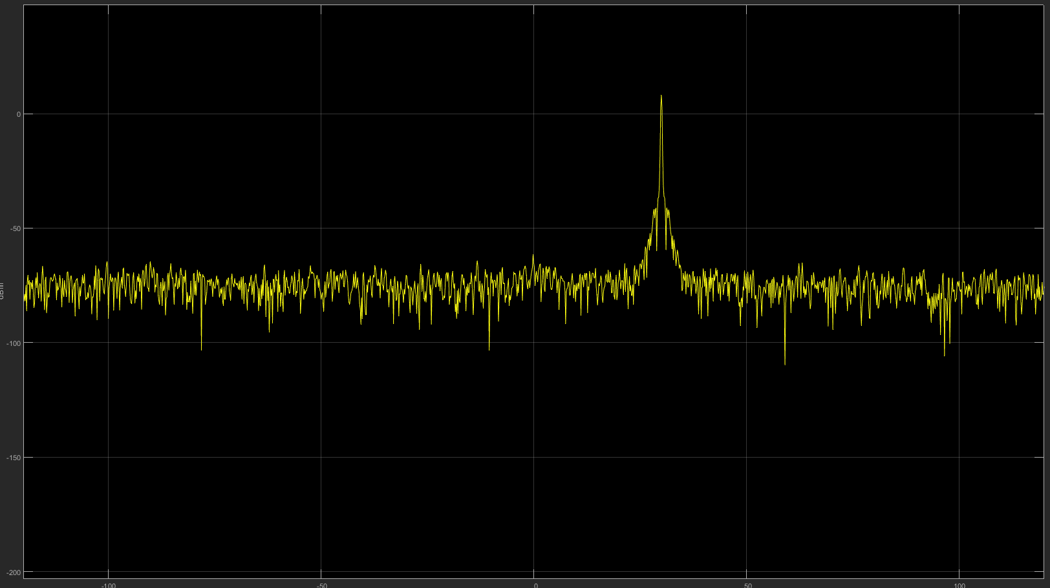

1. Spectrum (comment through the filter)